To create Table

CREATE TABLE Authors (

AuthorID INT PRIMARY KEY,

Name VARCHAR(255),

Bio TEXT

);

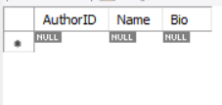

CREATE TABLE Books (

BookID INT PRIMARY KEY,

Title VARCHAR(255),

AuthorID INT,

Price DECIMAL(10,2),

PublicationDate DATE,

Genre VARCHAR(100),

FOREIGN KEY (AuthorID) REFERENCES Authors(AuthorID)

);

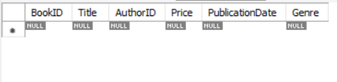

CREATE TABLE Sales (

SaleID INT PRIMARY KEY,

BookID INT,

QuantitySold INT,

SaleDate DATE,

FOREIGN KEY (BookID) REFERENCES Books(BookID)

);

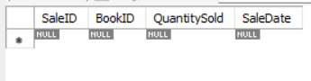

Adding Values to tables

To table books

INSERT INTO Books (BookID, Title, AuthorID, Price, PublicationDate, Genre)

VALUES

(1, 'To Kill a Mockingbird', 1, 12.99, '1960-07-11', 'Fiction'),

(2, '1984', 2, 10.99, '1949-06-08', 'Science Fiction'),

(3, 'The Great Gatsby', 3, 9.99, '1925-04-10', 'Fiction'),

(4, 'Pride and Prejudice', 4, 8.99, '1813-01-28', 'Romance');

To table Authors

INSERT INTO Authors (AuthorID, Name, Bio)

VALUES

(1, 'Harper Lee', 'Harper Lee was an American novelist widely known for To Kill a Mockingbird.'),

(2, 'George Orwell', 'George Orwell was an English novelist and journalist, best known for his dystopian novel 1984.'),

(3, 'F. Scott Fitzgerald', 'F. Scott Fitzgerald was an American novelist, known for his work The Great Gatsby.'),

(4, 'Jane Austen', 'Jane Austen was an English novelist known primarily for her six major novels, including Pride and Prejudice.');

To table Sales  
INSERT INTO Sales (SaleID, BookID, QuantitySold, SaleDate)

VALUES

(1, 1, 50, '2023-01-15'),

(2, 2, 30, '2023-02-20'),

(3, 3, 20, '2023-03-10'),

(4, 4, 40, '2023-04-05');

**Using DDL commands**

Alter command : added new column bio

ALTER TABLE Authors

MODIFY COLUMN Bio VARCHAR(500);

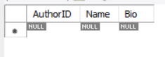

Using Drop to drop column  
Before

ALTER TABLE Books

ADD COLUMN NewColumn INT;

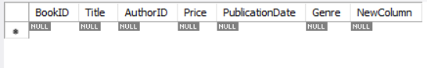

After

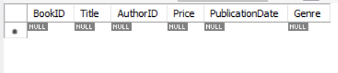

**Drop the Sales table**

DROP TABLE Sales;

Truncate Table

Before

INSERT INTO Books (BookID, Title, AuthorID, Price, PublicationDate, Genre)

VALUES

(1, 'To Kill a Mockingbird', 1, 12.99, '1960-07-11', 'Fiction'),

(2, '1984', 2, 10.99, '1949-06-08', 'Science Fiction'),

(3, 'The Great Gatsby', 3, 9.99, '1925-04-10', 'Fiction'),

(4, 'Pride and Prejudice', 4, 8.99, '1813-01-28', 'Romance');

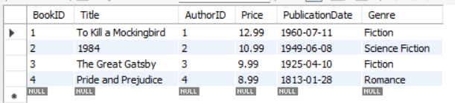

After   
TRUNCATE TABLE Books;

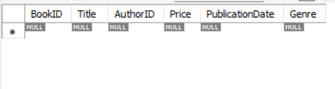

Use   
use test; (test - db)

Describe

Describe Books;

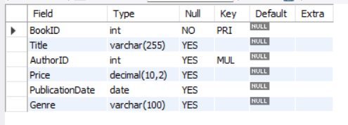

Show   
show databases;  
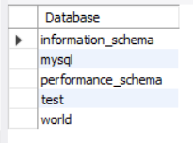

**Rename the Books table to BookList**

RENAME TABLE Books TO BookList;

Before 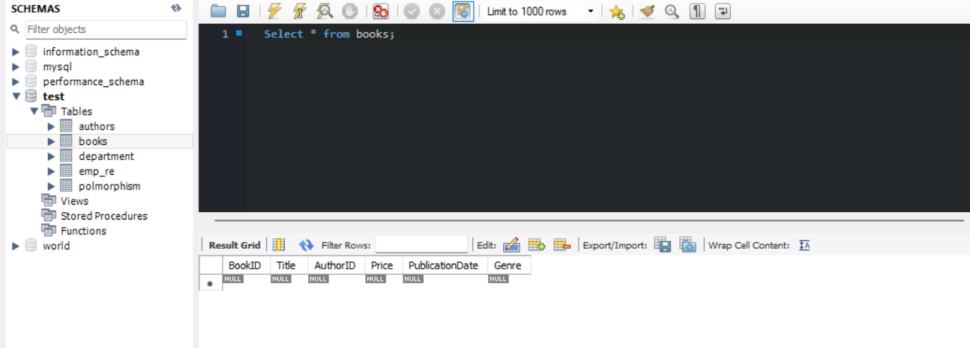

After

